October in Mahgs Month

Is there life after Kean?
Graduates of Kean’s acclaimed
Master of Arts in Holocaust and Genocide Studies
are involved in museums, human rights work,
and in privileged teaching positions.

Interested in joining their ranks?

What’s the Mahgs program about?
How long will it take before I receive my coveted Masters degree?
Is there financial aid?

Meet the director and learn about this exciting program!

Tuesday, October 24
12:30 pm in Townsend Hall 117
7:30 pm in Townsend Hall 111

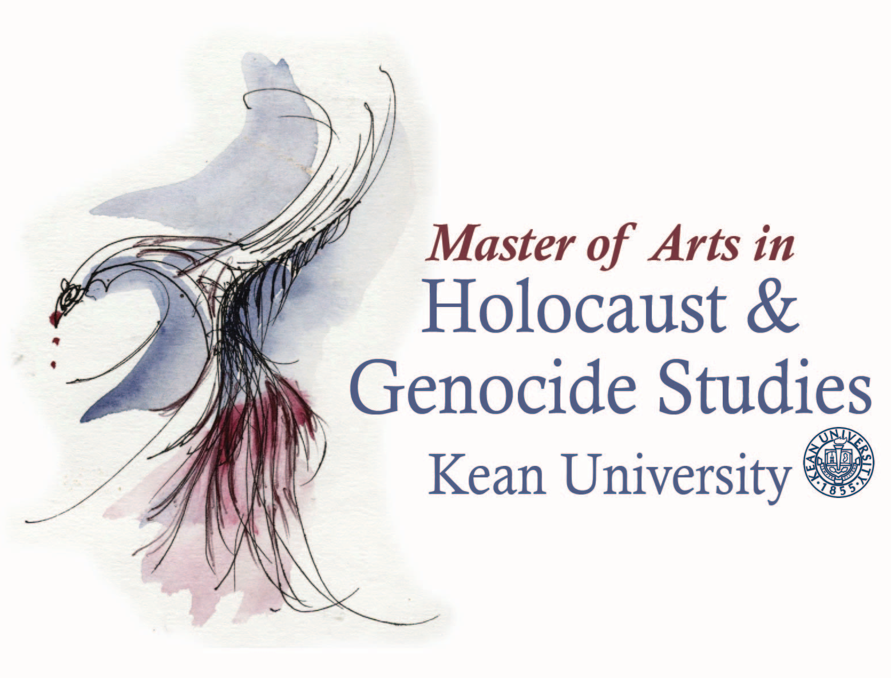

Master of Arts in Holocaust & Genocide Studies
grad.kean.edu/mahgs
dklein@kean.edu

