Can Genocide Be Prevented?
Two Views from Activists from Serbia and Uganda
October 18, 2 pm, Human Rights Institute

Srdjan Hercigonja
Serbia
Bosch Foundation Fellow

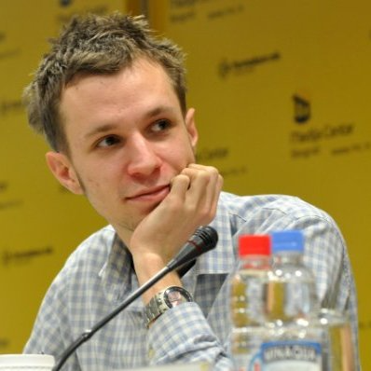
Srdjan Hercigonja is a junior researcher at the Belgrade-based Center for Comparative Conflict Studies. As an activist and scholar, his work is focused on conflict transformation, arts and politics in the context of post-conflict and postgenocide societies. During his fellowship this semester with theAlliance for Historical Dialogue and Accountability (Columbia University) he plans to develop a project that will focus on the ways in which victims of war crimes in Bosnia-Herzegovina, where no public recognition of atrocities has emerged, employ memory activism as a form of memorialization.

Lydia Mugambe
Uganda
Auschwitz Institute for Peace and Reconciliation (AIPR) Fellow

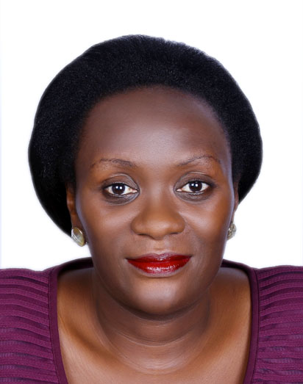
Lydia Mugambe is a lawyer from Uganda who was appointed in July 2013 as a Judge of the High Court in Uganda. Prior to this appointment, Lydia worked from 2005 to 2013 at the United Nations International Criminal Tribunal for Rwanda (UNICTR). In addition, she was a participant in the Global Raphael Lemkin Seminar for Genocide Prevention. During her fellowship this semester with the Alliance for Historical Dialogue and Accountability (Columbia University) she will develop a project around women in northern Uganda who have suffered severe human rights abuses, including rape, during the over 10-year civil war affecting their community.

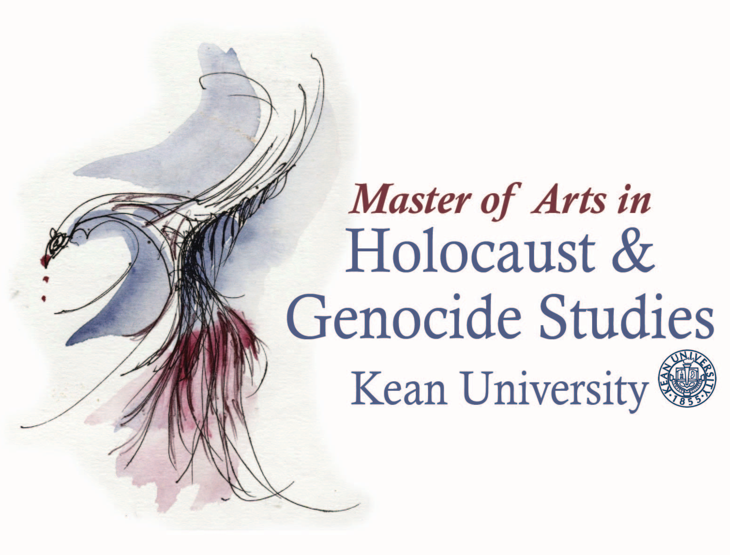
Sponsored by
Master of Arts in Holocaust & Genocide Studies
grad.kean.edu/mahgs
dklein@kean.edu

This Center for Interdisciplinary Studies event is cosponsored by the Jewish Studies Program in cooperation with Columbia University’s Alliance for Historical Dialogue and Accountability and is part of the Kean University course Justice and Human Rights.

